CESSNAS 2 OSHKOSH
KUNU RUNWAY 20 DEPARTURE
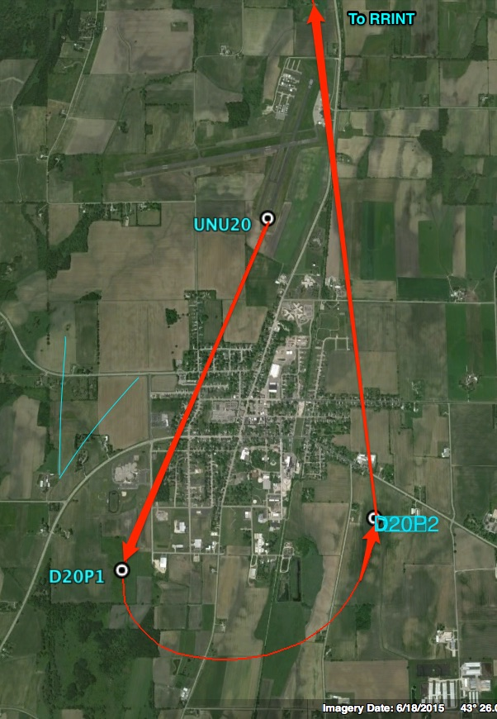
ORDER | WAYPOINT | LATITUDE | LONGITUDE
1 | UNU20 | 43° 25.295’ N | -88° 42.110’ W
2 | D20P1 | 43° 23.750’ N | -88° 42.975’ W
3 | D20P2 | 43° 23.975’ N | -88° 41.465’ W

